## **Scenario**

# 

# Review the scenario below. Then, complete the step-by-step instructions.

# You are a security professional at a large organization. You mainly work with their research team. Part of your job is to ensure users on this team are authorized with the appropriate permissions. This helps keep the system secure.

# Your task is to examine existing permissions on the file system. You’ll need to determine if the permissions match the authorization that should be given. If they do not match, you’ll need to modify the permissions to authorize the appropriate users and remove any unauthorized access.

# Note: This scenario involves investigating and updating the same file permissions as the ones in the [Manage authorization](https://www.coursera.org/learn/linux-and-sql/ungradedLti/483Kl/activity-manage-authorization) lab. You can revisit the lab to get screenshots to include in your portfolio document. If you choose, it's also possible to complete this activity without revisiting the lab by typing your commands in the template.

# File permissions in Linux

## Project description

Linux commands to configure authorization. In Linux, file and directory permissions are used to specify who has access to specific files and directories.So, in this project the linux commands are used to configure authentication.

## Check file and directory details

researcher2@59e718a76ef6:~$ cd projects

researcher2@59e718a76ef6:~/projects$ ls -la

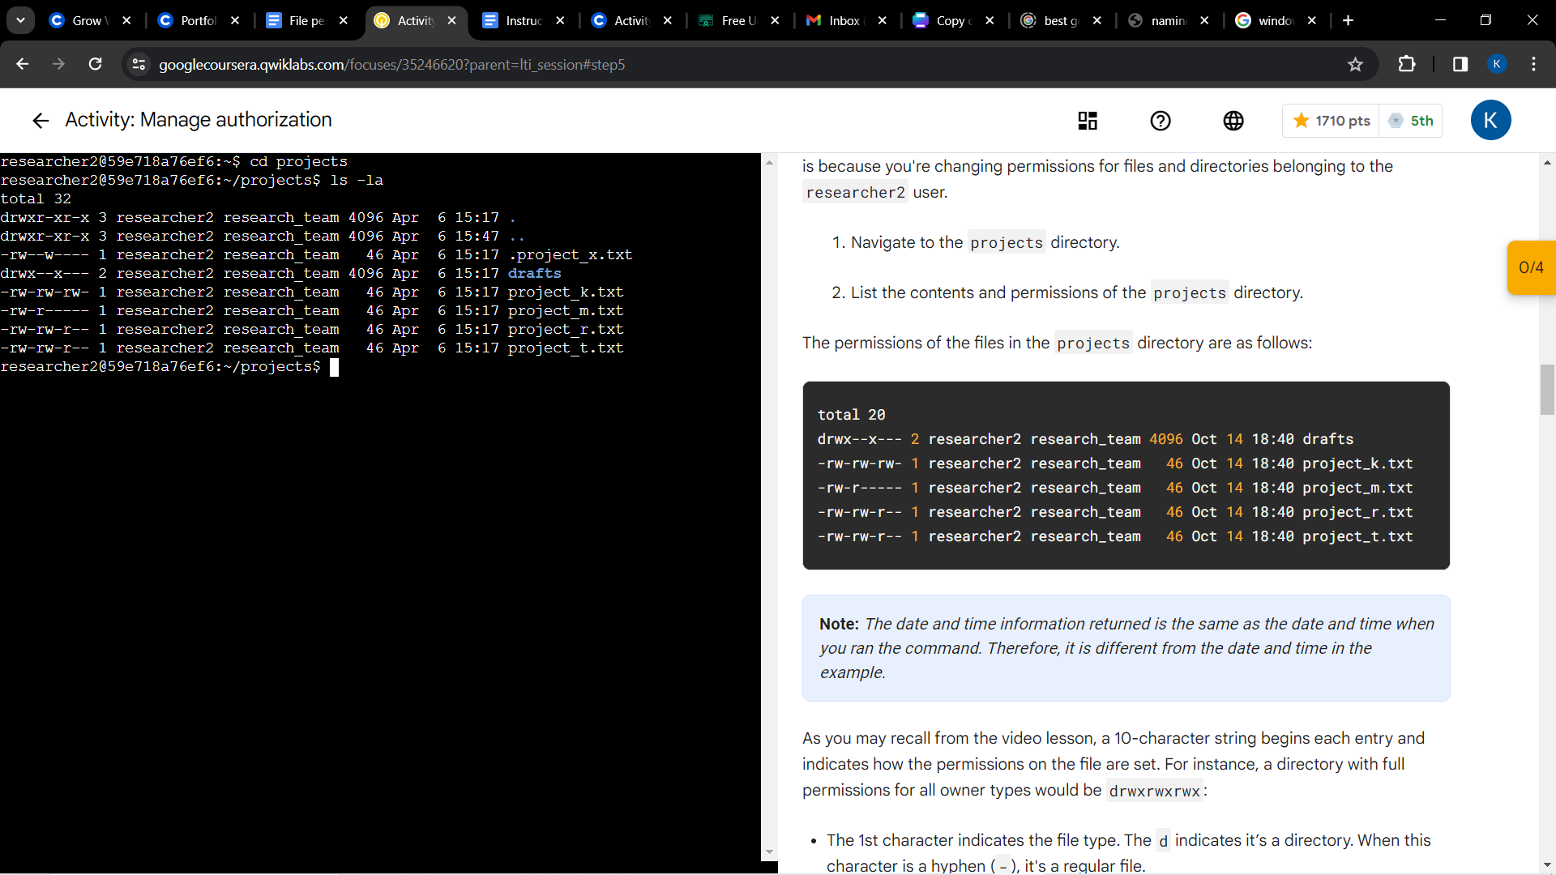

## Describe the permissions string

First three string elements represent the USER PERMISSIONS

Second three string elements represent the GROUP PERMISSIONS

Last three strings represent the OTHER PERMISSIONS.

Following string is example string taken from the lab

-rw-rw-rw- 1 researcher2 research_team 46 Apr 6 15:17 project_k.txt

In this permission string

| String Element | - | r | w | - | r | w | - | r | w | - |
| --- | --- | --- | --- | --- | --- | --- | --- | --- | --- | --- |
| Meaning | Shows a normal file | Users have access to read | Users have access to write | Users do not have access to execute. | Group has access to read | Group has access to write | Group do not have access to execute | Others have access to read | Others have access to write | Others do not have access to read |

## Change file permissions

researcher2@59e718a76ef6:~/projects$ chmod o-w project_k.txt

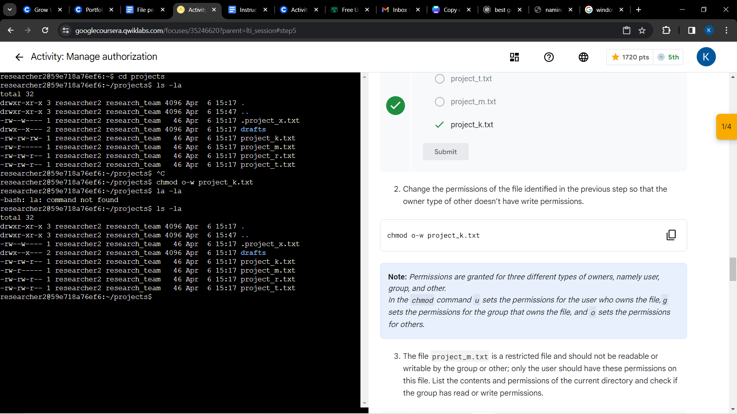

## Change file permissions on a hidden file

researcher2@59e718a76ef6:~/projects$ chmod u-w,g-w .project_x.txt

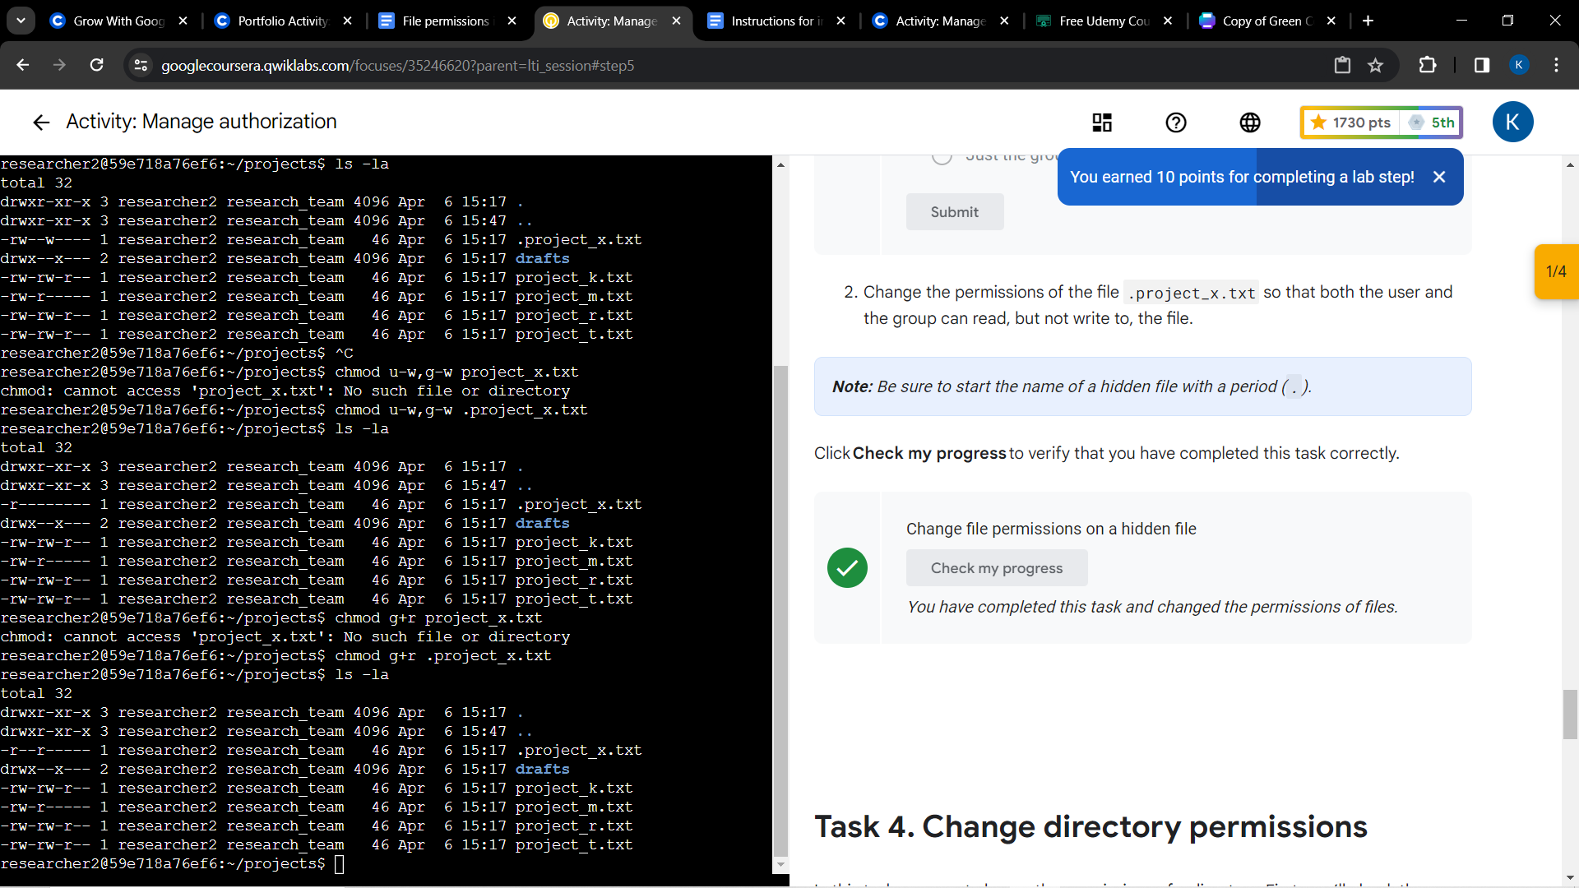

## Change directory permissions

researcher2@59e718a76ef6:~/projects$ chmod g-x drafts

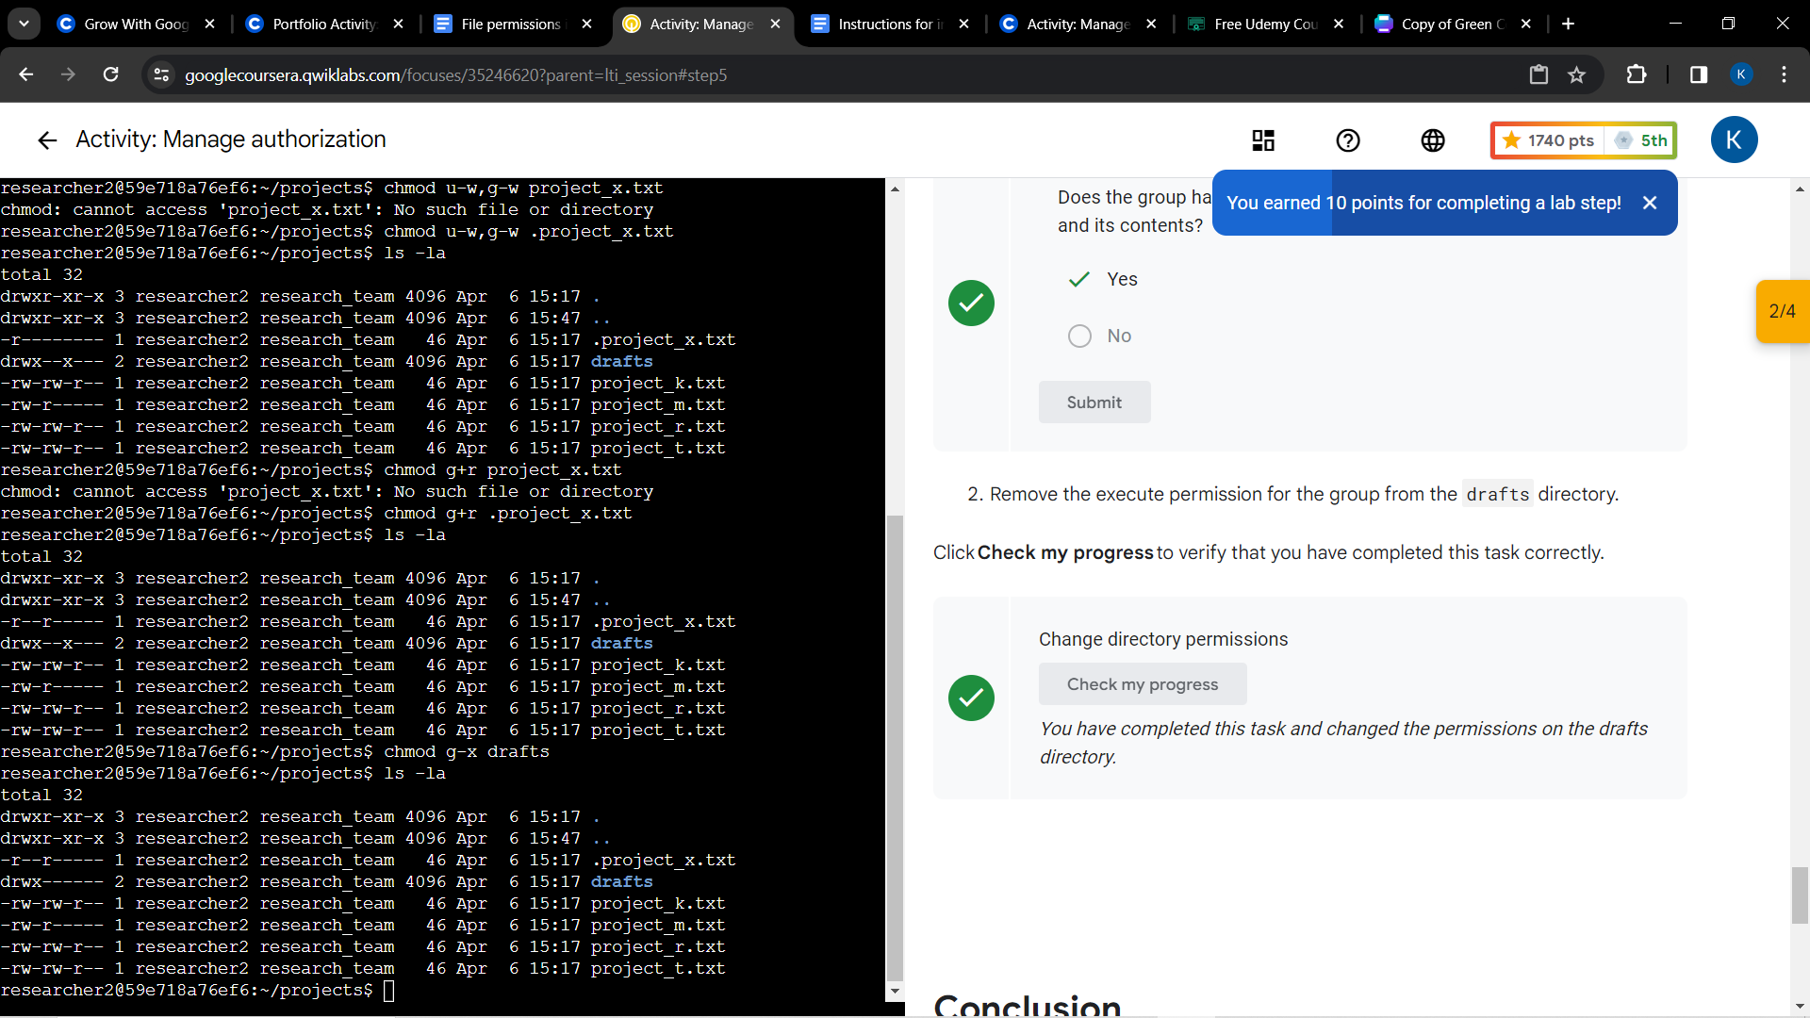

## Summary

Through this project we examined the permissions that the file or directory has and according to their needs or their role we ensured that there is minimal access to everyone.